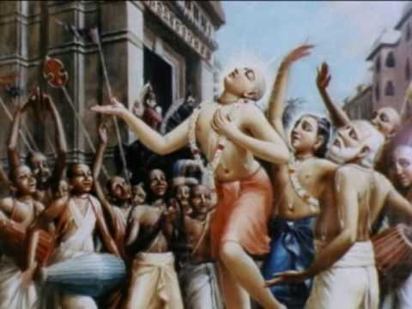
Soldiers of Godhead
June 2011 Edition
www.soldiersofgodhead.yolasite.com
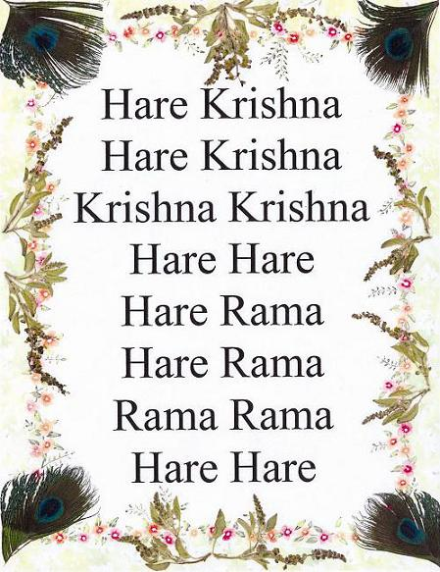
Chant Hare Krishna and be Happy!
Contents
Sr.no Topic Page no.
- FAITH 5

- The True Value of Krishna. 8

- The Plan of the Lord. 13

- Beyond the Ultimate Bore. 17

- Hari Nama in Kashmir! 19

- The Holy Name. 23

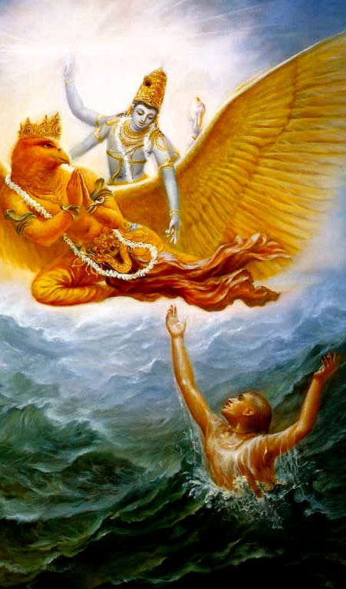
Lord Hari alone can save a conditioned soul from the ocean of material miseries.

- FAITH
A man just got married and was returning home with his wife. They were crossing a lake in a boat when suddenly a great storm arose. The man was a warrior, but the woman became very much afraid because it seemed almost hopeless -- THE BOAT WAS SMALL AND THE STORM WAS REALLY HUGE, AND ANY MOMENT THEY WERE GOING TO BE DROWNED. But the man sat silently, calm and quiet, as if nothingwas happening. The woman was trembling and she said, "Are you not afraid? This may be our last moment of life! IT DOESN'T SEEM THAT WE WILL BE ABLE TO REACH THE OTHER SHORE. Only some miracle can save us, otherwise death is certain. Are you not afraid? Are you mad or something? Are you a stone or something?" THE MAN LAUGHED AND TOOK THE SWORD OUT OF ITS SHEATH. The woman was even more puzzled -- what he is doing? Then he brought the naked sword close to the woman's neck -- so close that just a small gap was there, it was almost touching her neck. He said, "ARE YOU AFRAID?" She started to giggle and laugh and said, "WHY SHOULD I BE AFRAID? If the sword is in YOUR hands, why should I be afraid? I know you love me." He put the sword back and said, "This is my answer. I know Krishna loves me, and the sword is in His hands, and the storm is in His hands -- so WHATSOEVER IS GOING TO HAPPEN IS GOING TO BE GOOD. If we survive, good; if we don't survive, good -- because EVERYTHING IS IN KRISHNA'S HANDS, AND HE CANNOT DO ANYTHING WRONG."
This is the faith/trust one needs to imbibe. SUCH TREMENDOUS FAITH IS CAPABLE OF TRANSFORMING OUR WHOLE LIFE! And ONLY such tremendous faith is capable of transforming our life -- less than that won't do."
That's why Srila Rupa Goswami explains 'aadau shraddhaa' (CC Madhya 23.14-15) - first have faith, everything else follows faith.

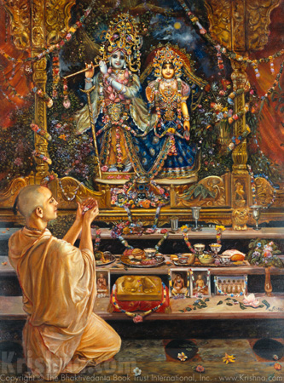
Krishna accepts whatever is offered to Him with love and devotion and rejects even the most opulent offering made without devotion.
- The True Value of Krishna
- By HG Devakinandan prabhu, disciple of His Holiness Mahavishnu Goswami Maharaj

One day Satyabhama was sitting with Krishna and at that point Narada muni comes and Satyabhama prays to Narada muni and says, "Welcome my dear Narada, what can I give you?" Narada muni says, "You can give me something which you consider to be most valuable." So she said I have many things which are valuable. She brought Narada into her room and she said, "See Krishna has given me all this wealth. He has given me diamonds, ear rings, bracelets, anklets everything.
They have so much value." Then Narada said, "Is this the most valuable item you have?" Satyabhama is devotee. So she says, "The person who has given me this is more valuable than all the valuable things that I have." So then Narada said, "Then I want that which is most valuable." So Satyabhama got trapped. She said the person who has given her all this is most valuable.
Therefore He is the one most precious to her. Just before then Narada had been asked by her what he wanted and she had agreed to give that to him. So when she said Krishna is most valuable to her, Narada said, "I will take Krishna with me. He is most valuable. So I will take Him with me." So Satyabhama begins to worry. She cannot bear to live in separation from Krishna. So she tells Narada muni, "I will give you something which is equal in value to Krishna. Is that alright?" Narada muni said, "If you can find that, I will be very happy."
So she says, "Krishna come here." We all know Krishna acted as a perfect hen-pecked husband of Satyabhama. Wherever Satyabhama says, "Krishna come", He will come. "Krishna, sit" and He will sit. "Krishna I want paarijaata flower" and He will take the whole tree. That is the greatness of Krishna.
So Krishna immediately came and said, "How can I serve you?" Satyabhama then told the servant to bring a large scale and then she says, "Krishna You sit on the left side." And immediately the scale goes down. So Satyabhama then looks around.
She goes to the room. She starts taking all the items of jewellery that Krishna had given her and she puts everything there confidently thinking that at some point the scale will become equal. Maharaj says that almost two hours had passed and she had put everything she has on the scale. Nothing left on her own body even. Krishna had not moved even an inch up. Then she calls all the other queens and asks them to bring all their jewellery. She puts everything on the pan and still Krishna does not move even an inch. Now she is really beginning to sweat. Narada Muni says, "If you cannot reach the value of Krishna, then I am going to take Krishna" and Krishna was just smiling and waiting to see the outcome. He does not want to interfere. Two great devotees are there. Better not to get into trouble. Just sit down and wait. Sometimes Maharaj says we are also caught in crossfire between two devotees. Both devotees want to serve Krishna and therefore they fight. When the two devotees are fighting for Krishna, better keep silent and be in the centre. That is the safest, Maharaj says. So Krishna sits down and waits.
Now Rukmini mata comes into the palace. Satyabhama calls Rukmini, "My dear sister, you must now help me." Maharaj says, Normally, Satyabhama doesn’t really like Rukmini mata so much. She is in the leftist camp and Rukmini is in the rightist camp. So little bit of tension is there sometimes, not so much from Rukmini’s side, but Satyabhama. Maharaj says Satyabhama has a bit of a heavy mentality. She likes to exert her authority over Krishna. So Rukmini mata comes in and she says, "What can I do?" Satyabhama explains that "Narada is going to take Krishna if we are not able to find something equal in value to Krishna. I have tried my best. All the jewellery in the palace is put and there is nothing left. Can you help me?" Rukmini mata becomes very upset. She says, “My dear sister Satyabhama, how can you really think that you can measure Krishna with any amount of material wealth?" All the wealth you have in the world cannot equal to Krishna and that is very true. The more wealth you have, the more you forget Krishna and the more you forget Krishna, the more anxious you become not for Krishna, but in forgetfulness of Krishna. So Rukmini mata said, "I know only one thing in this world which will really be equal to the value of Krishna." She goes outside and she picks one beautiful Tulasi leaf.
She comes inside and she prays very earnestly to Krishna, "Krishna, You please accept Tulasi maharani. She is Your dear most devotee. No one excels her in devotion. You please accept this with whatever little devotion I also have and if You can accept this, then You please be pleased with us. We do not want to lose You Krishna and Your value can never be measured." Saying like that,Rukmini mata throws all the jewellery aside and she puts Tulasi maharani on the pan and Krishna goes way up and Tulasi maharani goes way down. And Krishna starts laughing. Narada starts laughing. Satyabhama almost faints and she runs to Rukmini and says, "Now I know why you are the most favorite queen of Krishna because you realize the true value of Krishna."
It is such a simple story but is so deep because it tells us that very often we run after Krishna with all the material paraphernalia but we do not realize that He is not interested in that. He is interested only if you run after His devotees. Tulasi maharani is His devotee.
If you serve His devotees, then Krishna's value increases in our lives.

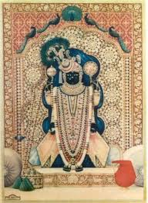

Lord Sri Dwarkadhish the presiding deity at Sri Dwarkadhish Temple, Sri Dham Dwarka, Gujarat, India.
- The Plan of the Lord.
-by His Holiness Srila Lokanath Swami Maharaj at Dwarkadheesh mandir, Dwarka)
Once there was a sweeper in Dwarkadheesh temple at Dwarka and he was very sincere and devoted. Every time he saw thousands of devotees coming to take darshan of the Lord, he thought that the Lord is standing all the time and giving darshan and He must be feeling very tired.
So one day very innocently he asked the Lord whether he can take the place of the Lord for a day so that the Lord can have some relief and rest. The Deity of the Temple replied, "I do not mind taking a break. I will transform you like Myself, but you must do one thing. You must just stand here like Me, smile at everyone and just give benedictions. Do not interfere with anything and do not say anything. Remember you are the deity and you just have faith that I have a master plan for everything." The sweeper agreed to this.
The next day the sweeper took the position of the deity and a rich man came and prayed to the Lord. He offered a nice donation and prayed that his business should be prosperous. While going, the rich man inadvertently left his wallet full of money right there. Now the sweeper in the form of deity could not call him and so he decided to control himself and keep quiet.
Just then a poor man came and he put one coin in the Hundi and said that it was all he could afford and he prayed to the Lord that he should continue to be engaged in the Lord's service. He also said that his family was in dire need of some basic needs but he left it to the good hands of the Lord to give some solution. When he opened his eyes, he saw the wallet left by the rich man. The poor man thanked the Lord for His kindness and took the wallet very innocently. The sweeper in the form of the Deity could not say anything and he had to just keep smiling.
At that point a sailor walked in. He prayed for his safe journey as he was going on a long trip. Just then the rich man came with the police and said that somebody has stolen his wallet and seeing the sailor there, he asked the police to arrest him thinking that he might have taken it. Now the sweeper in the form of Deity wanted to say that the sailor is not the thief but he could not say so and he became greatly frustrated. The sailor looked at the Lord and asked why he, an innocent person, is being punished. The rich man looked at the Lord and thanked Him for finding the thief. The sweeper in the deity form could no more tolerate and he thought that even if the real Lord had been here, he would have definitely interfered and hence he started speaking and said that the sailor is not the thief but it was the poor man who took away the wallet. The rich man was very thankful as also the sailor.
In the night, the real Lord came and He asked the sweeper how the day was.
The sweeper said, "I thought it would be easy, but now I know that Your days are not easy, but I did one good thing." Then he explained the whole episode to the Lord. The Lord became very upset on hearing this whereas the sweeper thought the Lord would appreciate him for the good deed done.
The Lord asked, "Why did you not just stick to the plan? You had no faith in Me. Do you think that I do not understand the hearts of all those who come here? All the donation which the rich man gave was all stolen money and it is only a fraction of what he really has and he wants Me to reciprocate unlimitedly. The single coin offered by the poor man was the last coin he was having and he gave it to Me out of faith. The sailor might not have done anything wrong, but if the sailor were to go in the ship that night he was about to die because of bad weather and instead if he is arrested he would be in the jail and he would have been saved form a greater calamity. The wallet should go to the poor man because he will use it in My service. I was going to reduce the rich man's karma also by doing this and save the sailor also. But you cancelled everything because you thought you know My plan and you made your own plans."
God has plans and justice for everyone.... We just have to have patience!!!!!
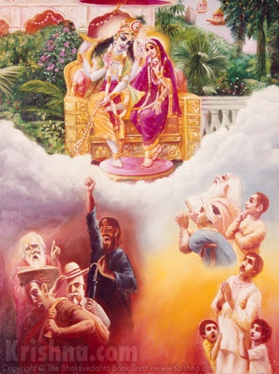

- Beyond the Ultimate Bore
We cannot enjoy this material world no matter how hard we try. Ultimately it is simply a bore. Although it sometimes appears that we are enjoying here, this is simply the trick of Maya, the illusory energy, to keep us perpetually entangled in the cycle of birth and death. Therefore, those who are wise do not try to squeeze pleasure out of this place where no factual pleasure exists. Instead they invest their time and energy where there is actually a payoff.
tasyaiva hetoh prayateta kovido
na labhyate yad bhramatam upary adhah
tal labhyate duhkhavad anyatah sukham
kalena sarvatra gabhira-ramhasa
"Persons who are actually intelligent and philosophically inclined should endeavor only for that purposeful end which is not obtainable even by wandering from the topmost planet [Brahmaloka] down to the lowest planet [Patala]. As far as happiness derived from sense enjoyment is concerned, it can be obtained automatically in course of time, just as in course of time we obtain miseries even though we do not desire them." ---Srimad Bhagavatam 1.5.18

So there is indeed a place that yields an inconceivable payoff, which is truly worthy of our time and energy. That place is the spiritual platform. How can we perceive it? How can we connect with it? How can we live on it? These are the sorts of questions that we should ask now that we are situated in this human form of life. If we do not ask such questions and instead simply run after money and sex pleasure, where are we? We are simply situated on the animal platform. Many will say, "What's wrong with that? I enjoy being an animal." But there is a profound difference between human life and animal life.
Animal life means that is one is forced to helplessly suffer the pains of material existence. Human life gives one the option of escaping all material miseries and entering into an eternal existence that is completely full with knowledge and bliss.
So the choice has to be made. No choice means we are stuck with the default position, the cycle of birth and death. Do we want to forego the cheap thrills of material existence in exchange for the ultimate happiness? Or would we rather continue to enjoy a few superficial pleasures every now and then, and remain in an embarrassing suffering condition, lifetime after lifetime, after lifetime?
- Sankarshan Dasa Adhikari

- Hari Nama in Kashmir!
-By His Grace Deena Bandhu Prabhu (ACBSP), Vrndavan
My dear Prabhujis,
Please accept my humble obeisances _/\ò_. All glories to Srila Prabhupada!
Our Prison Preaching Incharge, Jankinath Prabhu, decided to take out a Traveling Sankirtan Party for the summer. In their travels they reached Prabhupada Ashram in Uddhampur in Jummu, where HH Navayogendra Maharaja made very comfortable arrangements for their stay. From there they decided to go to Srinagar in Kashmir where they had the address of Colonel Ashok Kumar, who is a disciple of HH Gopal Krishna Maharaja and would provide them nice facilities for staying and preaching.
When they reached the entrance to Srinagar, there was an army checkpost. The soldiers told them that better not to take this bus with Hare Krishna written all over it into the city. Someone may get upset and attack it! You park it here in our camp and take a taxi. So they arranged a taxi and went to see one of Navayogendra Maharaja's disciples, Sudarshan Prabhu, who maintains a small preaching center there. He took them to Lal Chowk, the main Bazaar of Srinagar and the most tension filled place in the whole of India. When they got out of the car with Srila Prabhupada's books, suddenly they were inspired to do Hari Nama Sankirtan.
As soon as they started doing an ecstatic Hari Nama, everyone came to see what was happening. Shopkeepers as well as customers came out from the shops and everyone began to smile seeing the devotees chanting. Even from the offices people came out and all were very pleased to see Mahaprabhu's Sankirtan! Even some Muslims walked by and made shalom to them! They chanted all around this very historic place with everyone smiling at them. Suddenly a TV crew appeared, filming them, and soon other media persons arrived to take pictures!
They chanted for about a kilometer when they passed in front of a Muslim Women's College. All the girls and teachers came out to see and surrounded them. They all began to smile and appreciate the Sankirtan. Although it is very difficult to get these people to chant the Holy Name, still the devotees heard them mention oh, the Hare Krishna walas are here. Many times they could overhear them taking the Holy Name! Many soldiers of CRPF arrived with their weapons and began to watch the Hari Nama with pleasure. They told the devotees, don't worry we're protecting you!
They returned to the car and went to the famous Dal Lake where you can rent house boats to stay. Again they started doing Hari Nama and everyone was very happy to see them!
Afterwards they went to Colonel Ashok Kumar's house for prasadam. He was overjoyed to see the devotees. A couple of the Bengali devotees had been frightened to get out of the car and complained to him that Jankinath almost got them killed! Jankinath countered that you have to die one day, so if you die on the field doing Hari Nama, that is glorious! The Colonel immediately chimed in, if you die in the field that is glorious, no glory in dying in bed. He then joined them in an ecstatic kirtan and fed them nice prasadam!
Jankinath called Yasomatinandan prabhu in Ahmedabad and recounted the story to him. He was overjoyed and said this is very historic that you did Hari Nama in Lal Chowk in Kashmir. Today Srila Prabhupada is very pleased with you!
Unfortunately we don't have any fotos of the Hari Nama in Lal Chowk, but there is one on them chanting on Dal Lake. Jankinath is in the center and on the right is Sudarshan Das. The other picture is the kirtan at Colonel Ashok Kumar's house where you see him chanting enthusiastically with the devotees.
Sri Chaitanya Mahaprabhu ki jaya!
Srila Prabhupada ki jaya!
In service of Srimati Vrinda Devi,
Deena Bandhu dasa

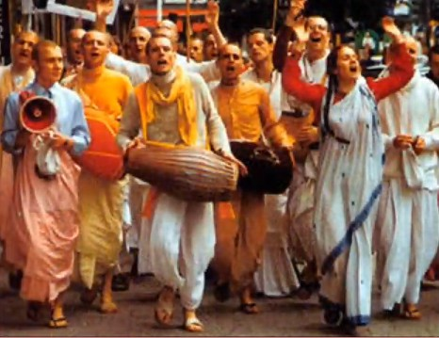

- The Holy Name.
Lecture on
Bhagavad-gita 7.8
23/02/74 Mumbai
By His Divine Grace A.C. Bhaktivedanta Swami Srila Prabhupada

With these present senses we cannot understand what is the holy, transcendental name of Krsna. Therefore sometimes we are misunderstood, that "Why these people are chanting Hare Krsna?" So... Because ordinary man or ordinary senses cannot understand the value, the nature of the name, therefore sastra says.. we can realize God by chanting name... Naama, the holy name of the Lord, is completely spiritual. ... name is as good as Krsna. . Those who are chanting Hare Krsna maha-mantra without any offense, they are tasting spiritual nectarine. Just like Rupa Gosvami has written a sloka that "If I could possess millions of ears and millions of tongues, then I could enjoy what is the transcendental mellow in chanting Hare Krsna maha-mantra. But that is not possible for ordinary human being in the beginning. Therefore sastra says, `These impurified senses cannot appreciate the value of the holy name of Krsna [Bhakti Rasaamrita Sindhu. 1.2.234]. . . As we go on chanting, Hare Krsna, Hare Krsna, Krsna Krsna, Hare Hare/ Hare Rama, Hare Rama ,Rama Rama, Hare Hare, and as we become purified... The more we chant, we become purified. ...It requires only realization that "Whole universe is Krsna." ... You have to understand by purified senses. That is required. Unless you have got purified senses, you cannot understand... So this thinking of Krsna is a process of devotional service, out of the nine processes ...[SB 7.5.23]. So if you remember Krsna, you advance in your spiritual life, and you become perfect yogi... What is the difference between spiritual and material? Everything is spiritual... But when it is covered by maayaa, it is material. That's all. And what is maayaa? Forgetful of Krsna. ..Our present senses are blunt senses because it is covered by forgetfulness of Krsna, or maayaa. Therefore it has to be purified. ... That's all. This is the process. ..Bhakti-marga, devotional service means purifying the senses..., at the present moment, our senses are covered by maayaa, and this maayaa can be moved away simply by remembering in every step Krsna.

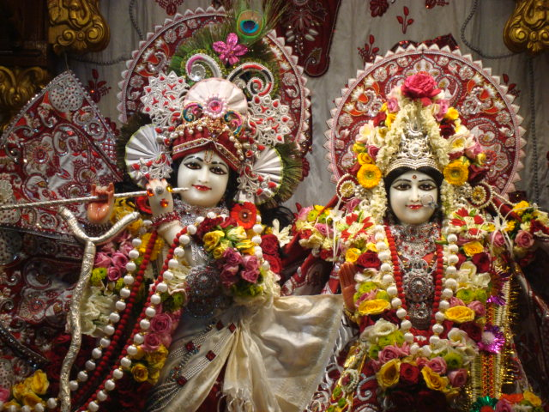
Dedicated at the Lotus feet of His Lordship
Sri Sri Radha Rasabihariji.

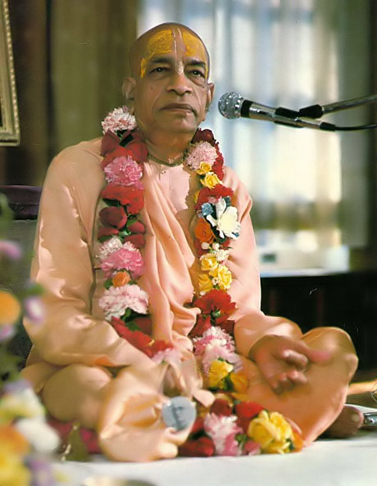
Dedicated to His Divine Grace A.C Bhaktivedanta Swami Prabhupada Founder Acharya of the International Society for Krishna Consciousness.
Written, Edited, Published and Distributed by,
Rasabihari Dasa

For more information log on to
www.soldiersofgodhead.yolasite.com

Send in your questions, comments and suggestions to vinay.chakraborty@yahoo.com

Chant Hare Krishna and be Happy!

Hare Krishna!

